# ASSIGNMENT NO-12

* **Problem Statement:-** Deploy and run project in AWS without using port.
* **Steps:**-
  + **EC2 creation:-**

1. In EC2 dashboard click **launch instances**. Give name,select **ubuntu** for hardware, architecture is 64-bit, instance type is t2.micro.

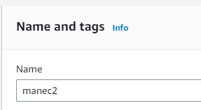 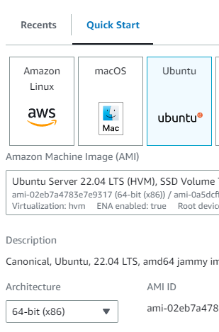

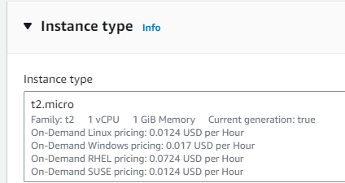

1. Give key pair(in case if u have it give existing one). In Network settings Firewall section click **select existing security group** and select the security group which is created previously(ex-mansecure1).

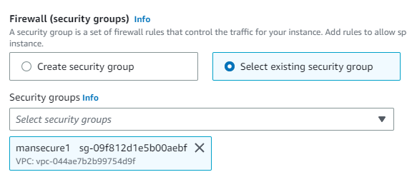

1. In Advance details , User data section type the following commands-

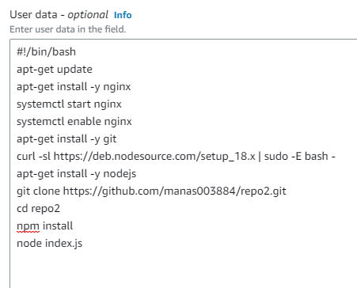

(In git clone line user can give his repo name and cd line the repo name will be according to his repo name.)

Now, click launch instances and the instance will be created.

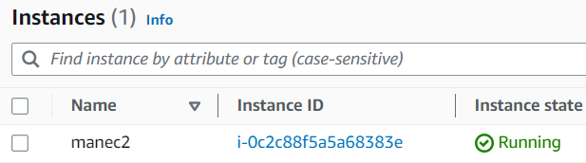

Now, copy public IPv4 address and run it with :4000 and we will get the website.

**Connect with Bitvise SSH:-**

1. Copy public IPv4 address(ex- 3.6.41.136) and paste it on Bitvise SSH Client.

Give username ubuntu, initial method publickey, in client key manager import that same existed key pair .pem file(ex-key003.pem) and click Global1 in Client key.and click log in.

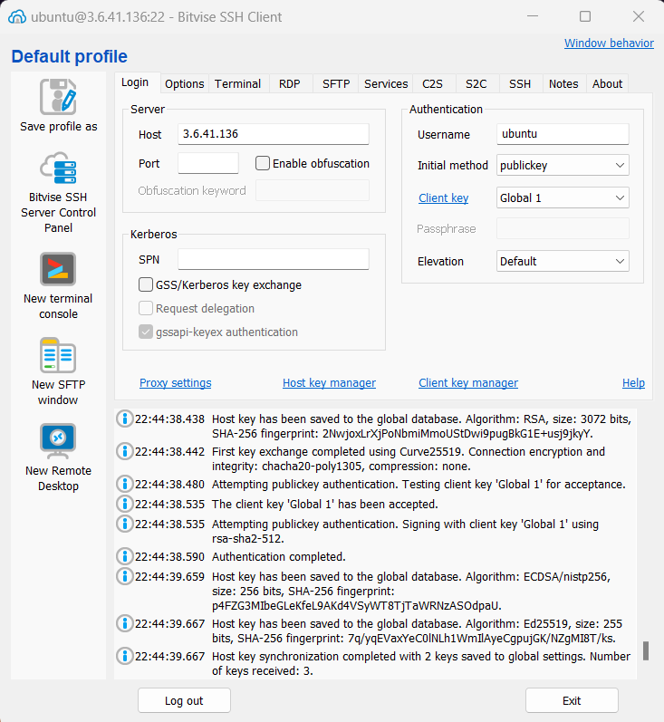

1. Now ,in terminal type the following commands-

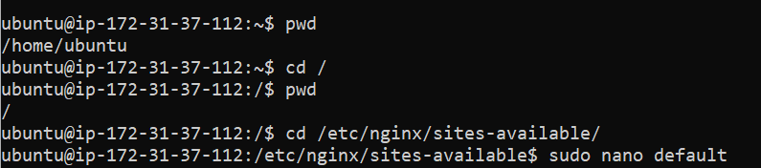

1. In the default file, edit the location to following-

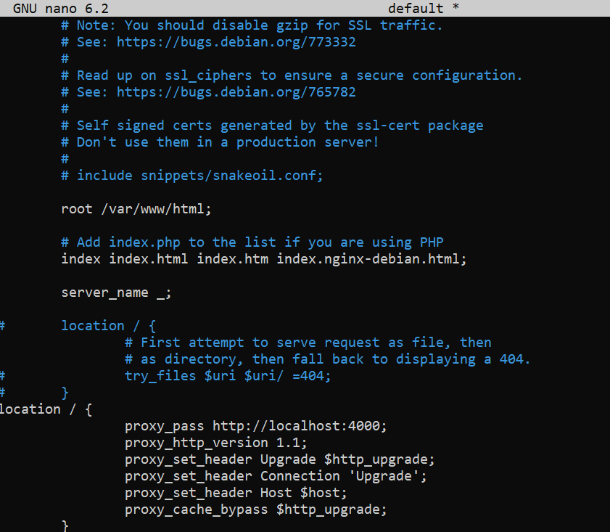

1. Now start the server by giving the following command**-“sudo systemctl restart nginx”.**



1. Now copy that IPv4 address and paste it in another tab and we can see that without port number the server is running.

